Jimi Porter

CIS 310-01

Due Date: 10/6/19

Week 7 Homework

1a) One and only one patient can have many orders, one order consists of many medications. Many orders belong to one patient and many medications make up one order.

1b) 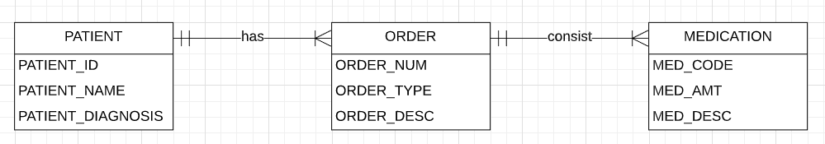

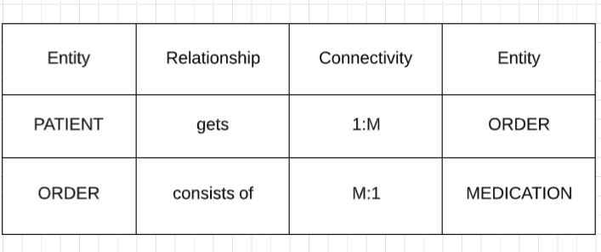

2a) The tables I would create are a PAINTER, PAINTINGS, and GALLERY table. The attributes for the PAINTER table would be PAINTER_ID, PAINTER_NAME, and PAINTER_COMMISSION. The attributes for the PAINTINGS table would be PAINTINGS_ID, PAINTINGS_LABEL, and PAINTINGS_DESC. The attributes for the GALLERY table would be GALLERY_NAME, GALLERY_CONTACT, and GALLERY_DESC.

2b) The business rules for this database would be one and only one painter can have many paintings, and many paintings can be displayed in one gallery. Then many paintings can be painted by one painter, and one gallery can show one or many paintings.

2c)

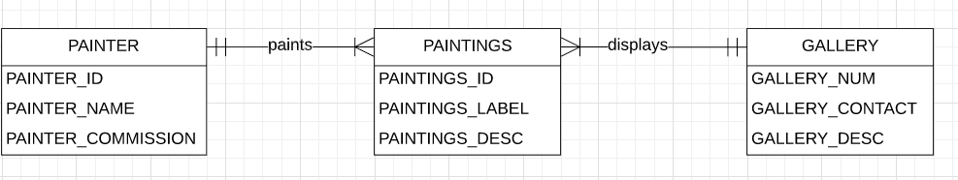

3)

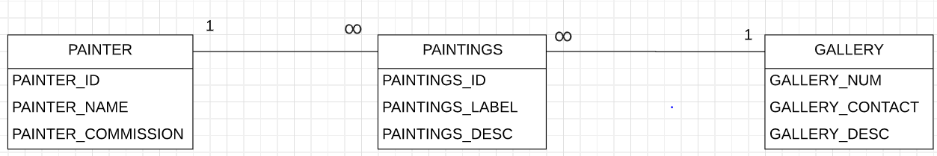

4)

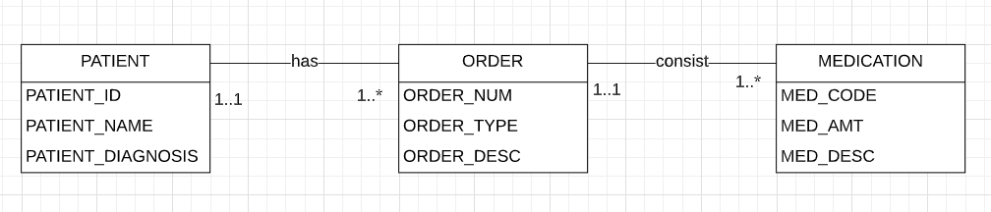

5) The business rules for this database are: One or many students have one professor, and one and only one professor teaches one or many classes. One and only one professor guides one or many students, and then one or many classes are taught by one and only one professor.

6)

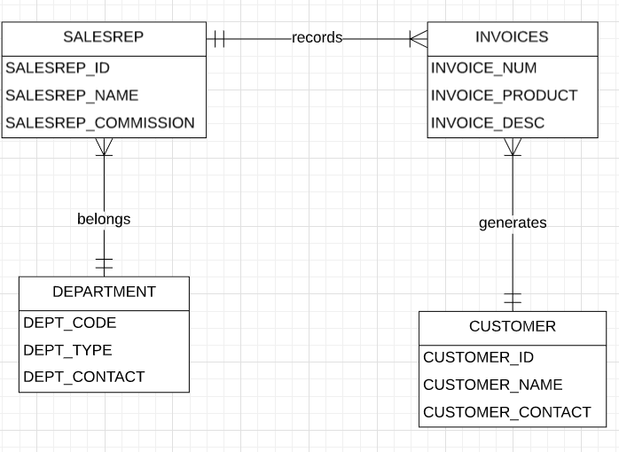

7) Normalization is concerned with evaluating and correcting the table structures in order to minimize data redundancies.

7a) The three forms are the first normal form (1NF), the second normal form (2NF), and the third normal form (3NF). The 1NF is where it describes the tabular format in which all the key attributes are defined, no repeating groups in the table, and all the attributes are dependent on the primary key. The 2NF is where the table is in 1NF and includes no partial dependencies. The 3NF is where the table is in 2NF and contains no transitive dependencies.

7b) The data modeling checklist has the business rules: which is properly documenting and verifying all business rules with the end users. This also ensures that all business rules are written precisely, clearly, and simply. The data modeling checklist identifies the source of all business rules and ensure that each business rule is justified, dated, and signed off by an approving authority. The checklist also includes entity names and entities, that should be in 3NF or higher and represent a single subject.